A MAJOR PROJECT REPORT ON

**DRUNK DRIVE DETECTION WITH CAR IGNITION**

**LOCK**

SUBMITTED IN PARTIAL FULFILLMENT FOR THE AWARD OF DEGREE OF

**BACHELOR OF TECHNOLOGY**

**IN**

### ELECTRONICS AND COMMUNICATION ENGINEERING



**SUBMITTED BY: UNDER THE GUIDANCE OF:**

CHAYAN GANDHI (9915102070) Dr. JITENDRA MOHAN

GEETA SHARMA (9915102072)

KAPIL GUPTA (9915102073)

**DEPARTMENT OF ELECTRONICS AND COMMUNICATION ENGINEERING**

**JAYPEE INSTITUTE OF INFORMATION TECHNOLOGY, NOIDA (U.P.) DECEMBER, 2018**

**CERTIFICATE**

This is to certify that the major project report entitled, **DRUNK DRIVE DETECTION WITH CAR IGNITION LOCK** submitted by **CHAYAN GANDHI (9915102070), GEETA SHARMA (9915102072) and KAPIL GUPTA (9915102073)** in partial fulfillment of the requirements for the award of Bachelor of Technology Degree in **Electronics and Communication Engineering** of the Jaypee Institute of Information Technology, Noida is an authentic work carried out by them under our supervision and guidance. The matter embodied in this report is original and has not been submitted for the award of any other degree.

**Signature of Supervisor:**

**Dr. Jitendra Mohan**

**Department of Electronics & Communication**

**JIIT, Sec-128, Noida-201304**

**Dated:**

# DECLARATION

We hereby declare that this written submission represents our own ideas in our own words and where others' ideas or words have been included, have adequately cited and referenced the original sources. We also declare that we have adhered to all principles of academic honesty and integrity and have not misrepresented or fabricated or falsified any idea/data/fact/source in our submission.

Place:

Date:

Name: Chayan Gandhi

Enrollment: 9915102070

Name: Geeta Sharma

Enrollment: 9915102072

Name: Kapil Gupta

Enrollment: 9915102073

## ACKNOWLEDGMENT

We would like to express our special thanks of gratitude to Dr. Jitendra Mohan who gave us the golden opportunity to do this wonderful project on the topic **DRUNK DRIVE DETECTION WITH CAR IGNITION LOCK**, which also helped us in doing a lot of Research and we came to know about so many new things we are really thankful to them. We would also like to express our sincere gratitude to our lab technicians for their help during the course by providing their expert academic and practical guidance.

Chayan Gandhi (9915102070)

Geeta Sharma (9915102072)

Kapil Gupta (9915102073)

TABLE OF CONTENTS

Certificate i

Declaration ii

Acknowledgement iii

List of Figures & Tables iv

Abstract v

CHAPTER 1. Introduction 1-4

1.1 Problem Statement 1

1.2 Need of System 2

1.3 Literature Survey 2-4

CHAPTER 2. System Architecture 5-11

2.1 Arduino NANO 5

2.2 Alcohol Sensor 7

2.3 DC Motor 8

2.4 LCD Display 9

2.5. Arduino IDE 10

CHAPTER 3. Experimental Details 12-13

CHAPTER 4. Results 14-15

4.1. Test Case: Initial Stage with No Alcohol 14

4.2. Test Case: Initial Stage with Alcohol below limit 15

4.3. Test Case: Initial Stage with alcohol above limit 15

4.4. Test Case: Running engine stopped 15

CHAPTER 5. Conclusion and Future Scope 16-17

5.1 Conclusion 16

5.2 Future Scope 17

References vi

**LIST OF TABLE AND FIGURES**

|  |  |  |
| --- | --- | --- |
| **Table No.** | **Table Name** | **Page No.** |
| 2.1 | Pin List of 16x2 LCD | 10 |

|  |  |  |
| --- | --- | --- |
| **Figure no** | **Figure Name** | **Page no** |
| 1.1 | Drunk Driving | 1 |
| 1.2 | Result of drunk driving | 2 |
| 1.3 | Motor Vehicle Act | 3 |
| 1.4 | Motor Vehicle Bill | 4 |
| 2.1 | Arduino Nano | 6 |
| 2.2 | MQ-3 | 7 |
| 2.3 | DC Motor | 8 |
| 2.4 | 16x2 LCD | 9 |
| 2.5 | Arduino IDE | 11 |
| 3.1 | Circuit Diagram | 12 |
| 3.2 | Schematic Circuit | 13 |
| 3.3 | Alcohol Limit graph | 13 |
| 4.1 | Result with no alcohol detected | 14 |
| 4.2(a) | Start engine | 15 |
| 4.2(b) | Alcohol Below limit | 15 |
| 4.3(a) | Start engine | 15 |
| 4.3(b) | Alcohol above limit | 15 |
| 4.4(a) | Start engine | 15 |
| 4.4(b) | Alcohol above limit | 15 |

# ABSTRACT

Driving under the influence of alcohol has affected and killed countless of people’s lives. If you drink and drive, not only do you possibly put yourself at risk, but your passengers and pedestrians, and other people, who were on the roads. Just think about that. Every thirty minutes someone’s life is cut short and families are devastated. So, here we implemented a prototype version Alcohol Detection system in order to control drunk and driving as much as we can.

The Alcohol Detection system works on a simple principle, if a driver has been drinking, the alcohol breath analyzer sensor will detect the level of alcohol in the driver’s breath and if it crosses a set threshold, an alert will come and the vehicle engine will stop immediately. This project design is for the safety of the people seating inside/outside the vehicle.

In the next scenario the levels of alcohol measured by the sensor and compared with the set in limits. If the set limit of consumption of alcohol is less than the alcohol consumed by the person, the system of activating relay is initiated which in turn activates the automatic lock on the vehicle, i.e. it stops the motor rotation if it is in running state or it unable it to start. The system will lock the Engine at the same time will automatically give a buzzer. By this, we can avoid accidents by checking the driving people on the roads

## CHAPTER - 1

## INTRODUCTION

Urbanization and growing affluence has led to more instances of drunk driving in India. Drunk driving or driving under the influence (DUI) is a criminal offence in India under the Motor Vehicle Act as shown in Fig 1.1.

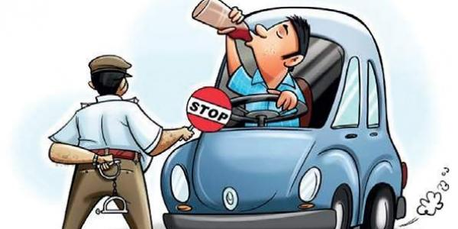

Figure 1.1: Drunk Driving

In India, the legal age for drinking varies from 18 years to 25 years from state to state, while some states have completely banned alcohol. For instance, state like Goa, Himachal Pradesh, Karnataka and others have a legal drinking age of 18 years. States like Delhi, Haryana and others have a legal drinking age of 25 years, while most states have a legal drinking age of 21 years. Consumption of alcohol is completely banned in the states of Gujarat, Bihar, Manipur and Nagaland, as well as the union territory of Lakshadweep.

**1.1 Problem Statement**

Any person who in his/her blood has alcohol exceeding 30 mg. per 100 ml. of blood, detected in a test by a breath Analyzer is said to be driving under the influence or drunk driving. The same also applies to any person who is under the influence of a drug to such an extent as to be incapable of exercising proper control over the vehicle.

The problem statement for our project is to prepare a cost-efficient Alcohol Detection system which works on the same simple principle, in order to achieve desired result and corresponding properties with ever-changing demands at device level.

**1.2 Need of study**

Drunk driving is the reason behind most of the deaths, so the Drunk Driving Detection with Car Ignition Locking Using Arduino aims to change that with automated, transparent, noninvasive alcohol safety check in vehicles.

Driving under the influence of alcohol has affected and killed countless of people’s lives. If you drink and drive, not only do you possibly put yourself at risk, but your passengers and pedestrians, and other people, who were on the roads as shown in Fig 1.2. Every thirty minutes someone’s life is cut short and families are devastated.

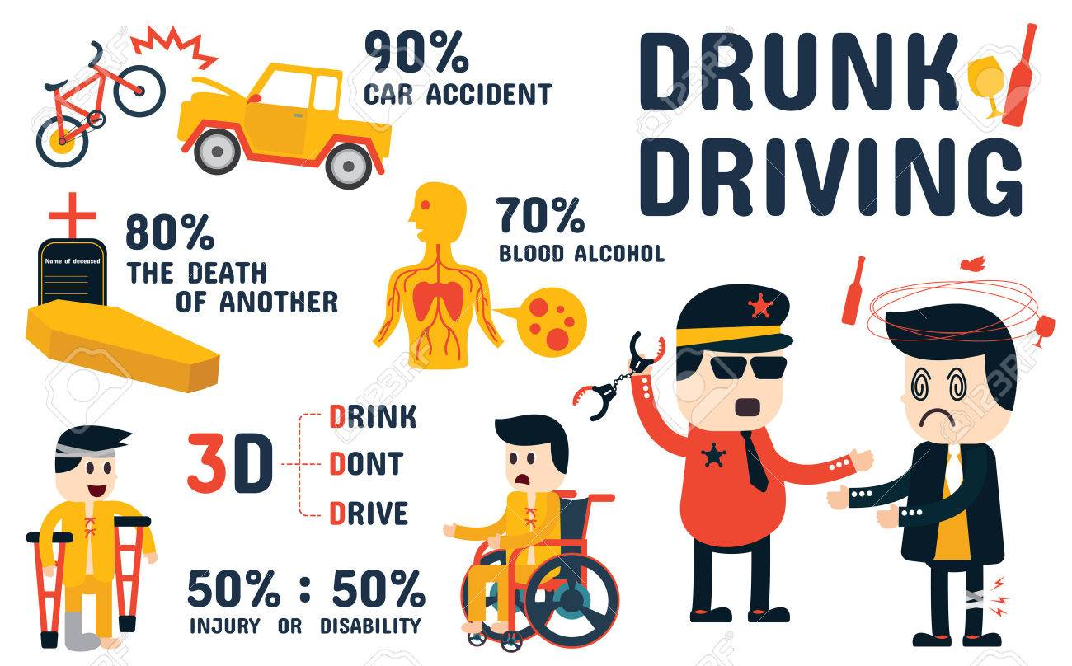

Figure 1.2: Result of drunk driving

So, here we implemented a prototype version Alcohol Detection system in order to control drunk and driving as much as we can.

**1.3 Literature Survey**

India had earned the questionable qualification of having more number of fatalities because of street mishaps on the society. Drinking and driving is as of now a genuine general medical issue, which is probably going to rise as a standout amongst the most critical issues sooner rather than later.

The primary reason behind this task is "Drunk driving detection". Since numerous mishaps are increasing due to the liquor utilization of the driver or the individual who is driving the vehicle. Numerous drivers drink and drive which is a criminal offense. Such drivers are

a danger to society and ought to be captured rapidly. Laws in India to check the drunken driving:

### 1.3.1 Section 185 of the Motor Vehicles Act, 1988

Driving by a drunken person or by a person under the influence of drugs. Whoever, while driving, or attempting to drive, a motor vehicle [1] :

1. Has, in his blood, alcohol exceeding 30 mg. per 100 ml. of blood detected in a test by a breath analyzer, or
2. Is under this influence of a drug to such an extent as to be incapable of exercising proper control over the vehicle, shall be punishable for the first offence with imprisonment for a term which may extend to six months, or with fine which may extend to two thousand rupees, or with both; and for a second or subsequent offence, if committed within three years of the commission of the previous similar offence as shown in Fig 1.3., with imprisonment for a term which may extend to two years, or with fine which may extend to three thousand rupees, or with both. Explanation.

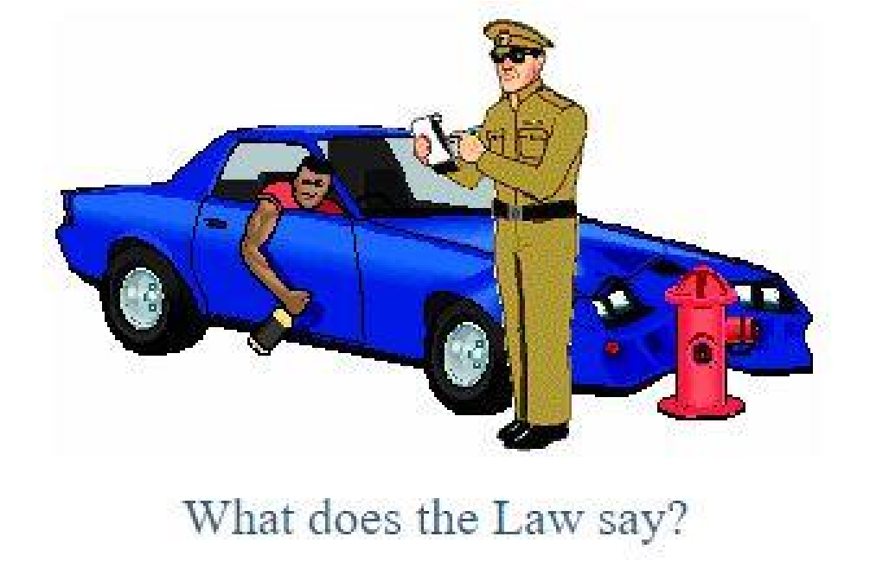

Figure 1.3. Motor vehicle Act

For the purposes of this section, the drug or drugs specified by the Central Government in this behalf, by notification in the Official Gazette, shall be deemed to render a person incapable of exercising proper control over a motor vehicle.

#### 1.3.2 Motor Vehicle (Amendment) Bill 2016

The Union Cabinet chaired by the Prime Minister Shri Narendra Modi has given its approval for Motor Vehicle (Amendment) Bill 2016 recently as shown in Fig 1.4. The Amendment bill aims to improve road safety and provides for higher level of fines and penalty for drunk driving. The penalty for drunk driving under the Motor Vehicle (Amendment) Bill 2016 has been increased from Rs.2000 to Rs.10, 000. This is one of the major offenses in India and those caught driving after consuming alcohol could be imposed a fine of Rs. 10,000. In this scenario, the driving license can be permanently cancelled if you are ever caught again for the same offense. [2]

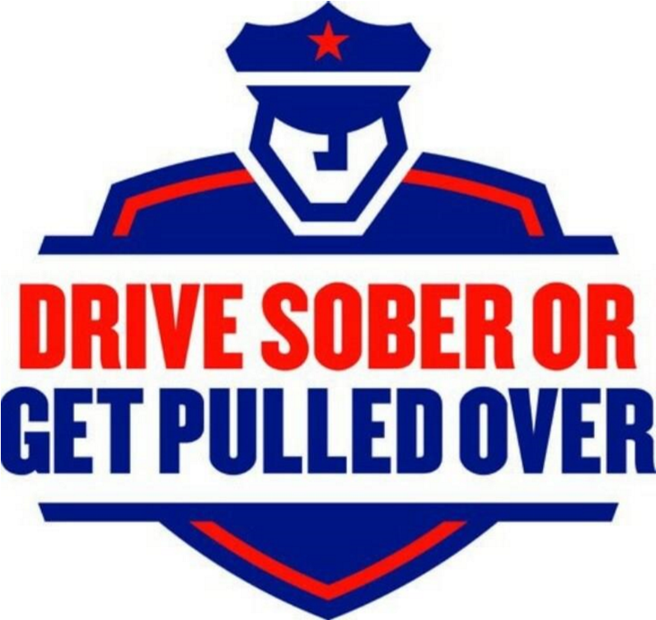

Fig 1.4 Motor Vehicle Bill

Limitation in the existing system:

* The existing system is an external system. The driver blow the device to find whether drink or not.
* The police are not able to check each and every car and even if they catch any one of the policeman can be easily bribed. So there is a need of an effective system to check drunken drivers.

## CHAPTER - 2

**SYSTEM ARCHITECTURE**

Here ATmega328P is used as Microcontroller Unit (MCU) which acts as the heart for the system. The framework comprises of these two sections:

**1. Sensor Part -** used to identify the centralization of alcohol all around and send the concentration as voltage signals to the accompanying part.

**2. Display Part -** used to get the prepared signal and demonstrate the information to users in LCD.

### The working of the system is when the driver sits, in position sensor gets activated and send alert abnormal condition to detect alcohol for the driver. Then the detection process starts and displays the amount of alcohol taken on Liquid Crystal Display (LCD). If the amount of alcohol detected is normal, the vehicle can start. If detects more than the alcohol allowed makes the vehicle cannot work if driver ignores the command and tries to start the car immediately breaks will activate and makes the wheels not to rotate.

### The ignition will begin only when the key touches +ve and –ve terminals with low o/p at the key terminal, the key fails to complete the circuit where it results in fuel supply cut-off to the engine. Thus, the engine stops working or doesn’t start depending on the position of the car.

### 2.1 Arduino Nano

The Arduino Nano is a small, complete, and breadboard-friendly board based on the ATmega328P, offers the same connectivity and specs of the UNO board in a smaller form factor as shown in Fig 2.1.

It has 14 digital input/output pins of which 6 can be used as PWM outputs, 6 analog inputs, a 16 MHz crystal oscillator, a mini-B USB connection, an ICSP header, and a reset button. It contains everything needed to support the microcontroller; simply connect it to a computer with a mini-B USB cable or power it with an AC-to-DC adapter or battery to get started. [3]

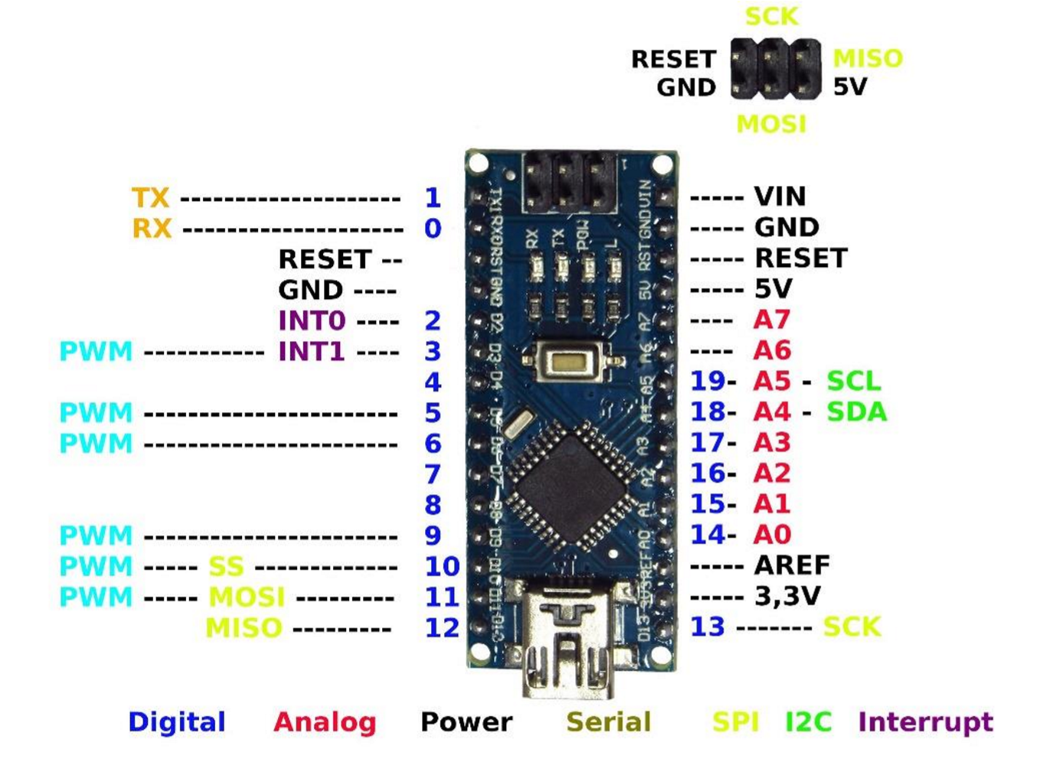

Figure 2.1: Arduino Nano

Each of the 14 digital pins on the Nano can be used as an input or output, using pinMode(), digitalWrite(), and digitalRead() functions. They operate at 5 volts. Each pin can provide or receive a maximum of 40 mA and has an internal pull-up resistor which is disconnected by default, of 20-50 kOhms.

**2.1.1 Technical specifications: -**

* Microcontroller ATmega328
* Operating Voltage (logic level): 5 V
* Input Voltage (Recommended): 7-12 V
* Input Voltage (limits): 6-20 V
* Digital I/O Pins : 14 (of which 6 provide PWM Output)
* Analog Input Pins: 8
* DC Current per I/O Pin: 40 mA
* Flash Memory 32 KB (ATmega328) of which 2 KB used by bootloader
* SRAM: 2 KB (ATmega328)
* EEPROM: 1 KB (ATmega328)
* Clock Speed: 16 MHz
* Measurements: 0.73" x 1.70"

#### 2.2 MQ3-Alcohol Sensor

MQ3- Alcohol Gas Sensor as shown in Fig 2.2 is a low-cost semiconductor sensor which, used to detect the presence of alcohol vapour gas. It has high sensitivity to alcohol and has a good resistance to disturbances due to smoke, vapour and gasoline. [4]

The sensitive material used for this sensor is SnO2, whose conductivity is lower in clean air. Its conductivity increases as the concentration of alcohol vapour gas increases. This module provides both digital and analog outputs.

This alcohol sensor is suitable for detecting alcohol concentration on your breath. It has a high sensitivity and fast response time. The sensor provides an analog resistive output based on alcohol concentration. The drive circuit is very simple, all it needs is a resistor. A simple interface could be a 0-3.3V ADC. The MQ3 alcohol sensor module can be easily interfaced with Microcontrollers, Arduino Boards, and Raspberry Pi etc.

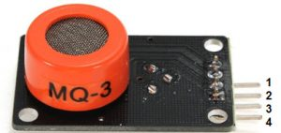

Figure 2.2: MQ-3

**Pin Out**

1. VCC – Input Power Supply
2. DO – Digital Output
3. AO – Analog Output
4. GND – Supply Ground

**2.2.1 Technical Specifications:**

* Current Consumption: 150mA
* Output sensitivity adjustable
* Analog output 0V to 5V and Digital output 0V or 5V
* Low Cost and Fast Response
* Stable and Long Life
* Fair Sensitivity to Alcohol Gas
* Both Digital and Analog Outputs
* Operation Temperature: -10°C ~ 70°C
* Concentration: 0.05 mg/L ~ 10 mg/L Alcohol
* Operating Voltage: 5V ± 0.1

### 2.3 DC Motor

DC Motors are electromechanical devices which use the interaction of magnetic fields and conductors to convert the electrical energy into rotary mechanical energy as shown in Fig 2.3. Electrical DC Motors are continuous actuators that convert electrical energy into mechanical energy. The DC motor achieves this by producing a continuous angular rotation that can be used to rotate pumps, fans, compressors, wheels, etc. A DC motor consists of two parts, a Stator which is the stationary part and a Rotor which is the rotating part. This type of motor

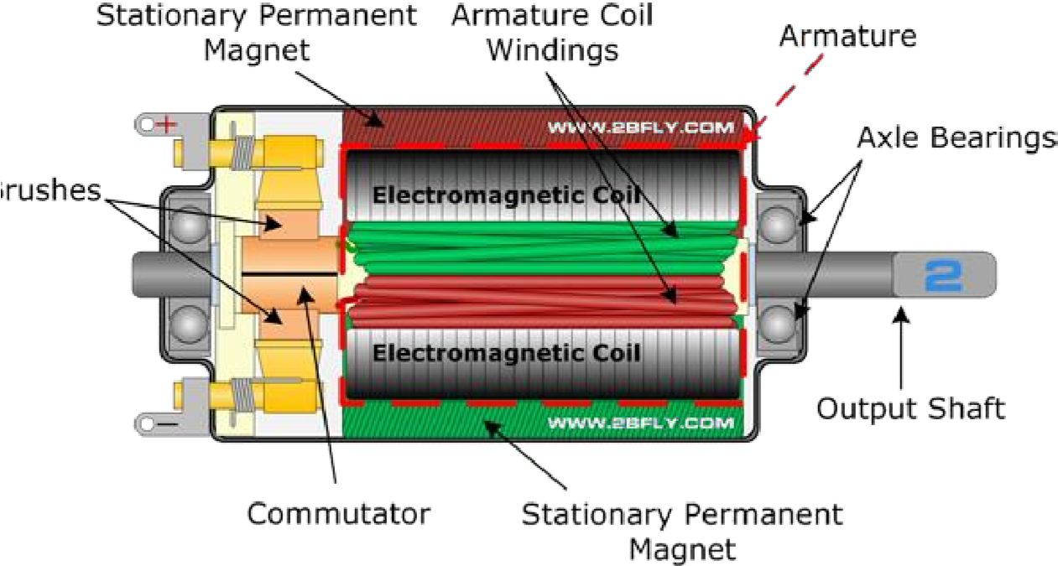

Figure 2.3: DC Motor

produces a magnetic field in a wound rotor, the part that rotates by passing an electrical current through a commutator and carbon brush assembly. The stators, the stationary part magnetic field is produced by using either a wound stator field winding or by permanent magnets.

### 2.4 LCD Display

We come across [LCD](https://electronicsforu.com/videos-slideshows/videos/building-liquid-crystal-display-lcd) displays everywhere around us. Computers, calculators, television sets, mobile phones, digital watches use some kind of display to display the time as shown in Fig 2.4. An LCD is an electronic display module which uses liquid crystal to produce a visible image. The 16×2 LCD display is a very basic module commonly used in [DIYs](https://electronicsforu.com/category/electronics-projects/hardware-diy) and circuits. The 16×2 translates a display 16 characters per line in 2 such lines. In this LCD each character is displayed in a 5×7 pixel matrix. [5]

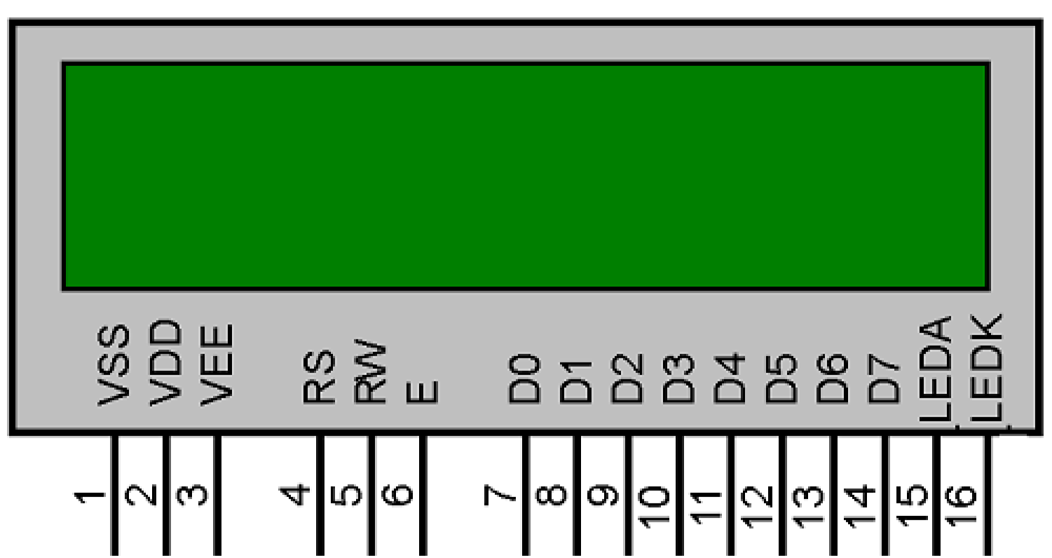

Figure 2.4: 16x2 LCD

A 16X2 LCD has two registers, namely, command and data. The register select is used to switch from one register to other. RS=0 for command register, whereas RS=1 for data register.

The command register stores the command instructions given to the LCD. A command is an instruction given to LCD to do a predefined task like initializing it, clearing its screen, setting the cursor position, controlling display etc. Processing for commands happens in the command register.

The data register stores the data to be displayed on the LCD. The data is the ASCII value of the character to be displayed on the LCD. When we send data to LCD it goes to the data register and is processed there. When RS=1, data register is selected.

**2.4.1 Pin List16x2 LCD**

|  |  |  |
| --- | --- | --- |
| **Sr. No** | **Pin No.** | **Pin Description** |
| 1 | Pin 1 (GND) | This is a ground pin to apply a ground to LCD. |
| 2 | Pin 2 (VCC) | This is the supply voltage pin to apply voltage to LCD. |
| 3 | Pin 3 (VEE) | This is the pin for adjusting a contrast of the LCD display by attaching a variable resistor in between VCC and GND. |
| 4 | Pin 4 (RS) | RS stands for Register Select. This pin is used to select command/data register.  If RS=0 then command register is selected.  If RS=1 then data register is selected. |
| 5 | Pin 5 (R/W) | R/W stands for Read/Write. This pin is used to select the operation Read/Write.  If R/W=0 then Write operation is performed.  If R/W=1 then Read operation is performed. |
| 6 | Pin 6 (EN) | En stand for Enable signal. A positive going pulse on this pin will perform a read/write function to the LCD. |
| 7 | Pin 7-14 (DB0-DB7) | This 8 pin is used as a Data pin of  LCD. |
| 8 | Pin 15 (LED+) | This pin is used with pin 16(LED-) to setting up the illumination of back light of LCD. This pin is connected with VCC. |
| 9 | Pin 16 (LEC-) | This pin is used with pin 15(LED+) to setting up the illumination of back light of LCD. This pin is connected with GND. |

Table No 2.1 Pin List of 16x2 LCD

**2.5. Arduino IDE**

A program for Arduino may be written in any [programming language](https://en.wikipedia.org/wiki/Programming_language) for a compiler that produces binary machine code for the target processor as shown in Fig 2.5. Atmel provides a development environment for their microcontrollers, AVR Studio and the newer Atmel Studio.

The Arduino project provides the Arduino integrated development environment (IDE), which is a cross-platform application written in the programming language Java. It originated from the IDE for the languages Processing and Wiring. It includes a code editor with features such as text cutting and pasting, searching and replacing text, automatic indenting, brace matching, and syntax highlighting, and provides simple one-click mechanisms to compile and upload programs to an Arduino board. It also contains a message area, a text console, a toolbar with buttons for common functions and a hierarchy of operation menus. A program written with the IDE for Arduino is called a sketch. Sketches are saved on the development computer as text files with the file extension .ino. Arduino Software (IDE) pre-1.0 saved sketches with the extension .pde.

The Arduino IDE supports the languages C and C++ using special rules of code structuring. The Arduino IDE supplies a software library from the Wiring project, which provides many common input and output procedures. [6] User-written code only requires two basic functions, for starting the sketch and the main program loop, that are compiled and linked with a program stub main() into an executable cyclic executive program with the GNU tool chain, also included with the IDE distribution. The Arduino IDE employs the program avrdude to convert the executable code into a text file in hexadecimal encoding that is loaded into the Arduino board by a loader program in the board's firmware.

A minimal Arduino C/C++ sketch, as seen by the Arduino IDE programmer, consist of only two functions:

* Setup (): This function is called once when a sketch starts after power-up or reset. It is used to initialize variables, input and output pin modes, and other libraries needed in the sketch.
* loop (): After setup() has been called, function loop() is executed repeatedly in the main program. It controls the board until the board is powered off or is reset.

Most Arduino boards contain a [light-emitting diode](https://en.wikipedia.org/wiki/Light-emitting_diode) (LED) and a load resistor connected between pin 13 and ground, which is a convenient feature for many tests and program functions. A typical program for a beginning Arduino programmer blinks a LED repeatedly. 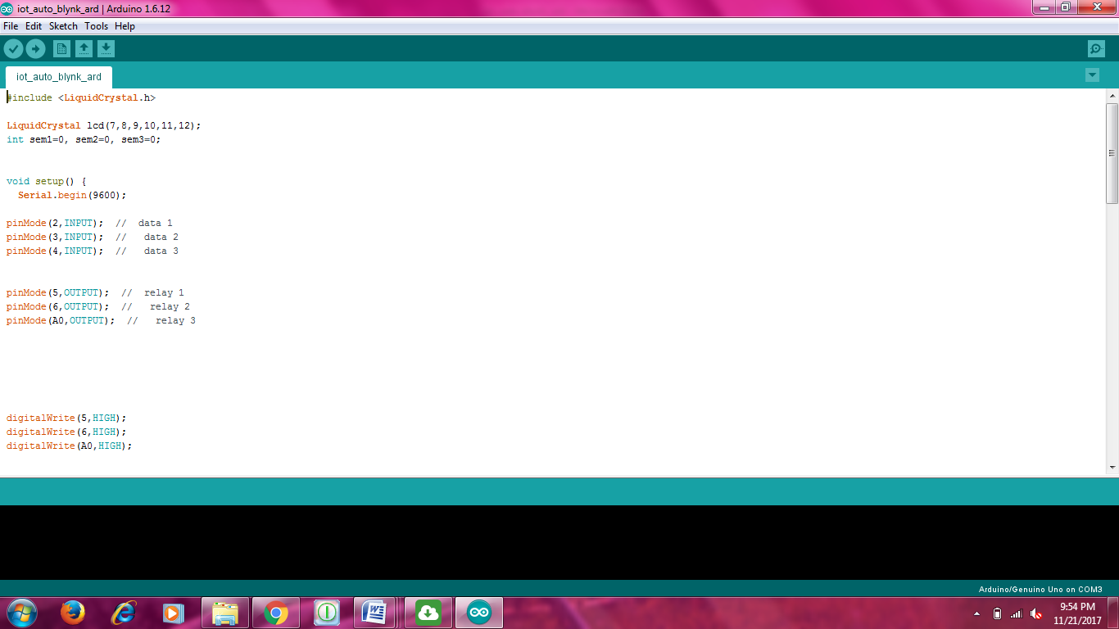

Figure 2.5. Arduino IDE

## CHAPTER 3

## EXPERIMENTAL DETAILS

The system uses Arduino NANO with alcohol sensor, dc motor, and LCD display circuit to achieve this purpose as shown in Fig 3.1 and schematic circuit in Fig 3.2.

* Alcohol sensor and Arduino NANO with dc motor to demonstrate as vehicle engine.
* System constantly monitors the sensitivity of alcohol sensor for drunk driver detection.
* If driver is drunk as per the alcohol limit graph as shown in Fig 3.3, the processor instantly stops the system ignition by stopping the motor. If alcohol sensor is not giving high alcohol intensity signals, system lets engine run.
* The Arduino NANO processor constantly processes the alcohol sensor data to check drunk driving and operates a lock on the vehicle engine accordingly.

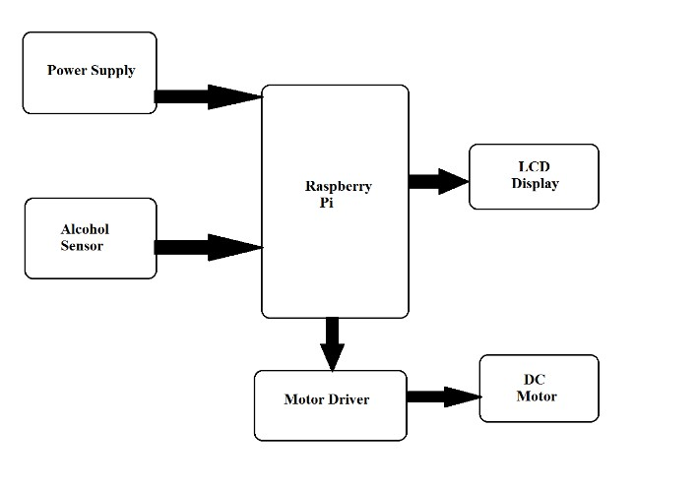

**Arduino Nano**

Figure 3.1: Circuit Diagram

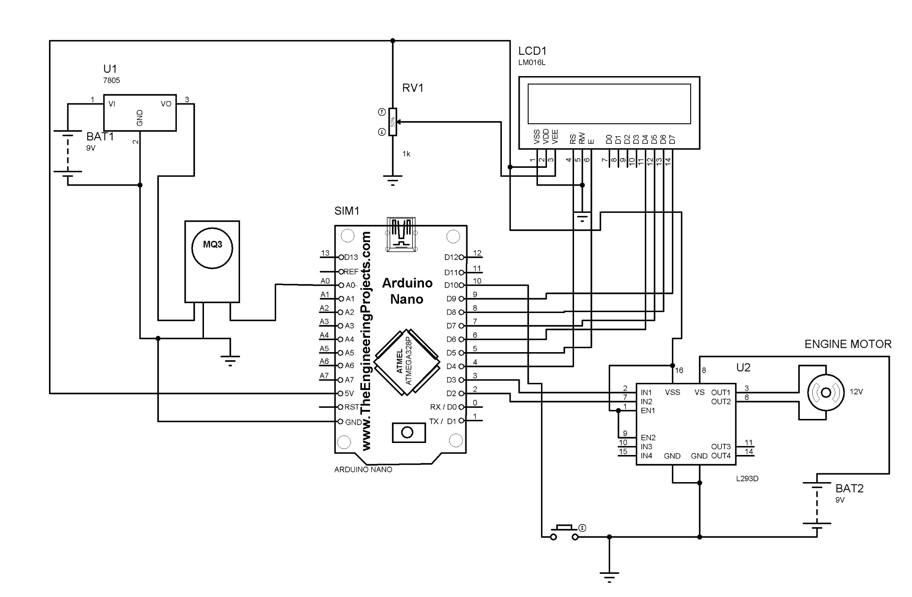Figure 3.2: Schematic Circuit

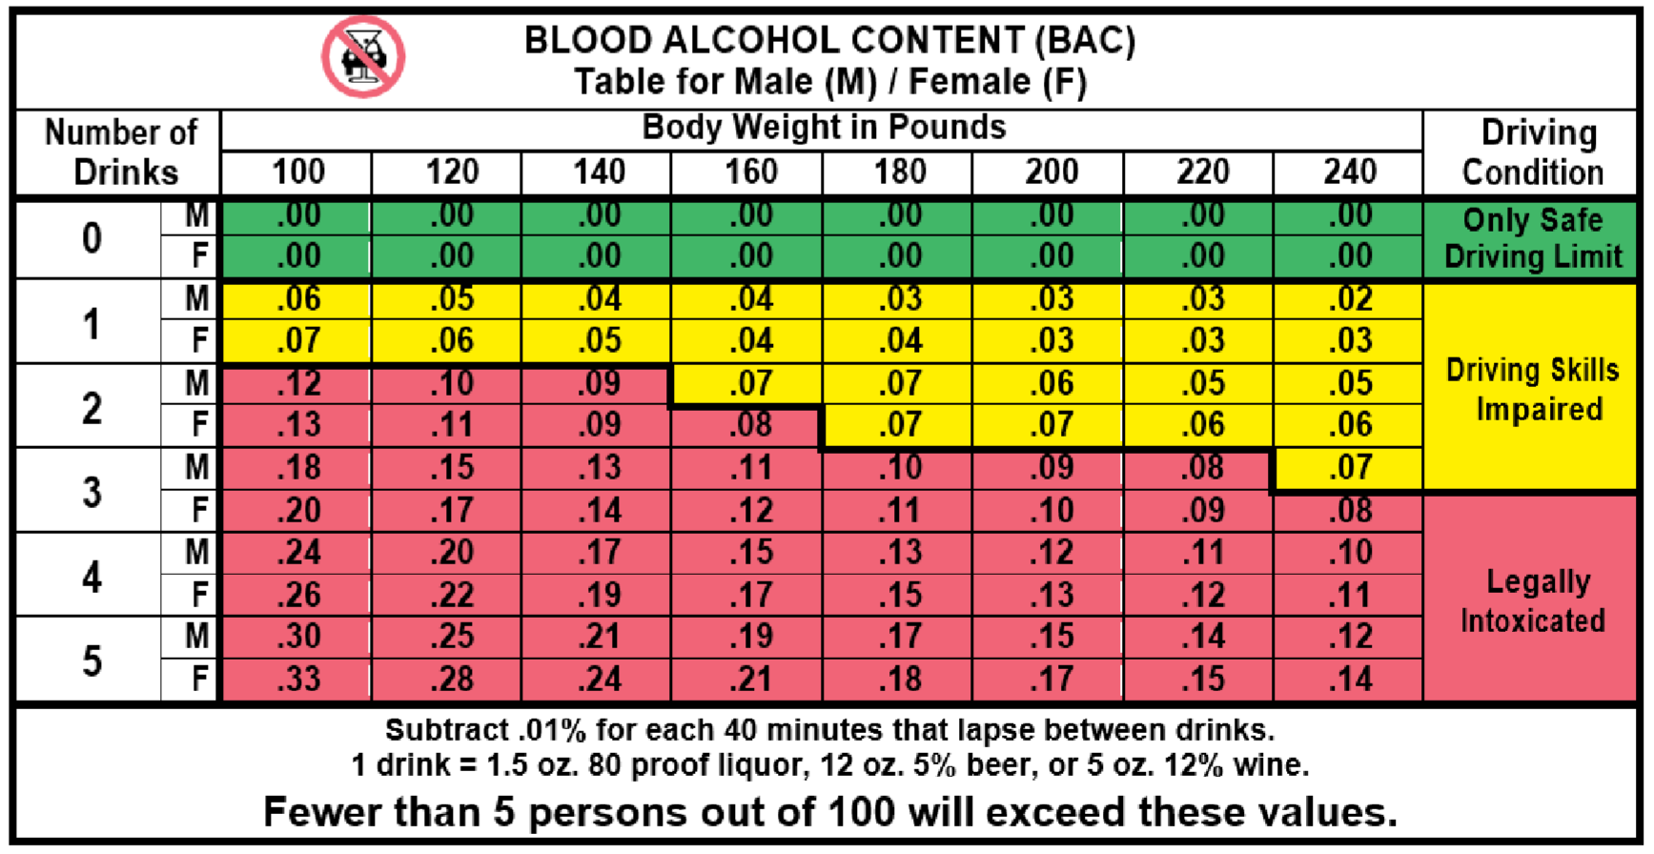

Figure 3.3: Alcohol Limit graph

## CHAPTER 4

**RESULT**

The following procedure explains the procedure of flow:

* When driver starting car/vehicle then alcohol sensor starts sensing at condition vehicle speed equal to zero.
* If alcoholic driver detected then immediately ignition system will turn off along with message about detection is send to relevant of driver for notification and notification will be displayed on LCD.
* A flag is set when first condition is passed without detection of alcohol.
* When speed of vehicle is greater than zero. i.e. vehicle started to driving then again along with alcohol, start to sense collected parameter values are send to microcontroller.
* If alcohol detected in this case then signal is sent to fuel blocker by microcontroller for blocking fuel supply to ignition system. So, driver feel’s that vehicle is going to stop and then place car at appropriate location.
  1. **Test Case: Initial Stage with No Alcohol**

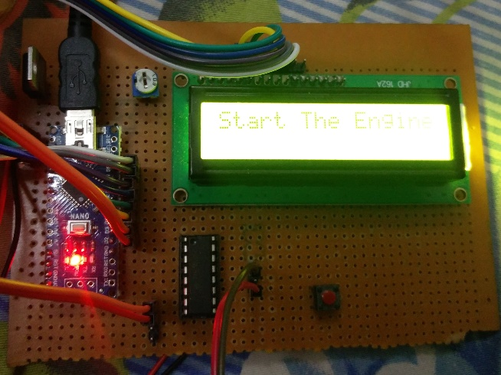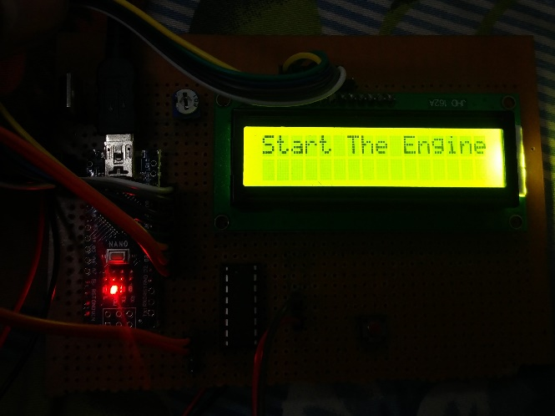

4.1(a) 4.1(b)

Fig 4.1(a) & 4.1(b): Result with no alcohol detected

* 1. **Test Case: Initial Stage with Alcohol below limit**

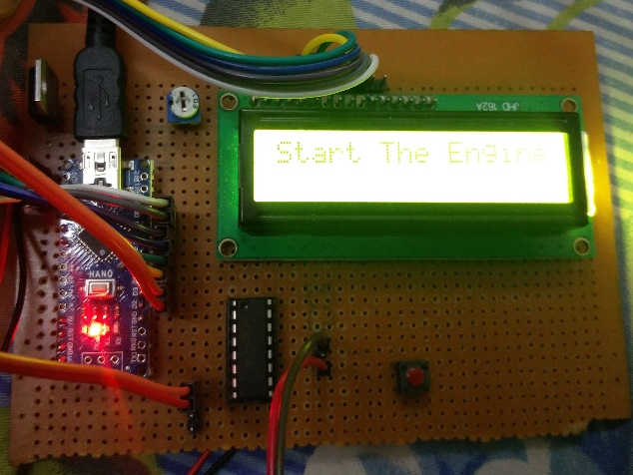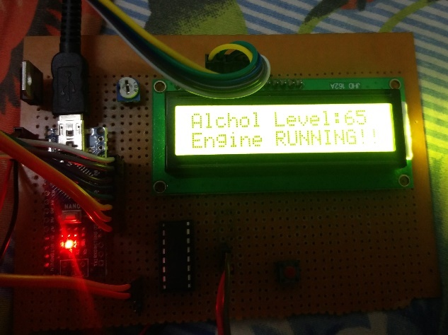

Fig 4.2(a): start engine Fig 4.2(b): Alcohol below limit

* 1. **Test Case: Initial Stage with alcohol above limit**

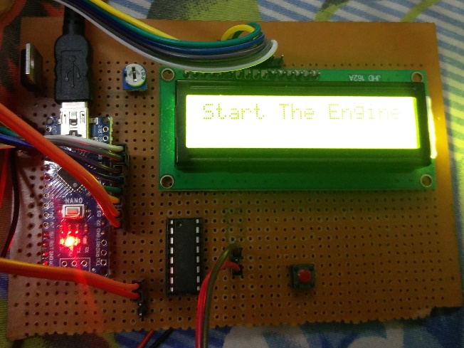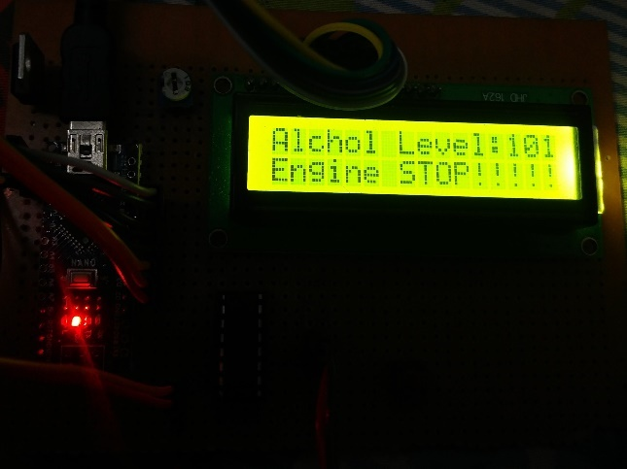

Fig 4.3(a): Start engine Fig 4.3(b): Alcohol above limit

* 1. **Test Case: Running engine stopped**

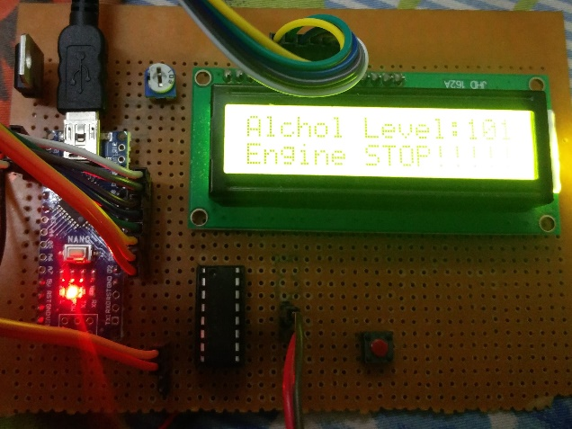

Fig 4.4(a): Start engine Fig 4.4(b): Alcohol above limit

**CHAPTER – 5**

**CONCLUSION AND FUTURE SCOPE**

### 5.1. Conclusion

This project has resulted designing, analyzing and building a prototype of the smart drink and drunken driver detection and safety system for vehicles. Proposed system will efficiently detect alcohol through driver breath and stop the vehicle by suspending the ignition, instead of directly stopping the vehicle and curtail the catastrophic effects it can have on peoples’ lives. The smart alcohol detection and safety system for vehicles prototype has been built and test runs have been carried out for the analysis of the system

Now a days car collisions are mostly observed. By fitting this alcohol sensor into the car, we can save the life of the driver and furthermore the rest of the travelers. The life time of the task is high. It has low or zero support cost and obviously low power utilization. This is a developed system to check drunken driving.

In the coming years, such a system is going to be mandatory in vehicles and is going to play a major role in making lives secure during driving. Drunk-driver detection in vehicles makes better fleet management with high potential to save lives. Such a system in a vehicle will help parents to avoid the kids to drink and drive.

An effective solution is provided to develop the intelligent system for vehicles which will monitor various parameters of vehicle in-between constant time period .This system brings innovation to the existing technology in the vehicles and also improves the safety features, hence proving to be an effective development in the automobile industry.

By executing this outline a safe car travel is possible decreasing the mishap rate because of drinking. By executing this outline, drunken drivers can be controlled so are the mishaps because of drunken driving.

**5.2. Future Scope**

In this paper the device prototype with preliminary experimental results depicting proofof-the-concept was presented. To ascertain long-term working performance of the system more live tests with different level of drunken state of the driver can be conducted and analyzed.

The system reliability can further be enhanced by the use of multi-sensor fusion using breath-based sensors at different locations in the vehicle i.e. the system measures blood alcohol levels from a driver’s breath and the levels would be detected from sensors mounted in front of the driver, but the driver wouldn’t even need to be aware they are being monitored with the vision system to recognize facial/eyes expressions of the driver and/or use of touch sensor i.e. screen for alcohol when the driver touches the start button, or another designated surface in the car and alcohol levels would be measured under the skin’s surface on a touch-pad with an infrared light scanner etc.

There is possibility to incorporate others features such as different security mechanism in the vehicle such as theft, accident detection, fuel quality detection along with vehicle tracking system. Further, developing the system on the latest VANET technologies will help to share the information with others on the road effectively and efficiently.

In Future work, Government must authorize laws to introduce such circuit in each car and must manage all car organizations to preinstall such systems while manufacturing the car itself. If it is achieved the death rate because of drunken drivers can be brought to least level. In this kind of system, securely landing of car aside without disturbing other vehicles can also be added as a future extension.

**REFRENCES**

[1] <https://en.wikipedia.org/wiki/Alcohol_laws_of_India>

[2] <https://www.prsindia.org/billtrack/the-motor-vehicles-amendment-bill-2016-4366>

[3] <https://store.arduino.cc/usa/arduino-nano>

[4] <http://wiki.seeedstudio.com/Grove-Gas_Sensor-MQ3/>

[5] <https://electronicsforu.com/resources/learn-electronics/16x2-lcd-pinout-diagram>

[6] <https://en.wikipedia.org/wiki/Arduino_IDE>